Status | Name | Condition | After Repairs
Adopted by:  Susan Berryhill and Dusty Williams | Tommie Greer | 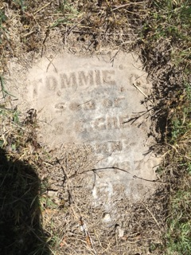
Adopted by: Susan Berryhill and Dusty Williams | Eva Greer | 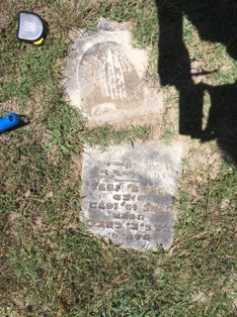 | 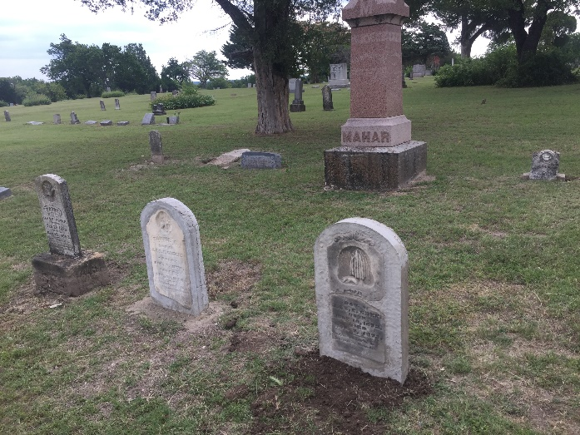
Adopted by Debbie Perkins | George O. Sunderland | 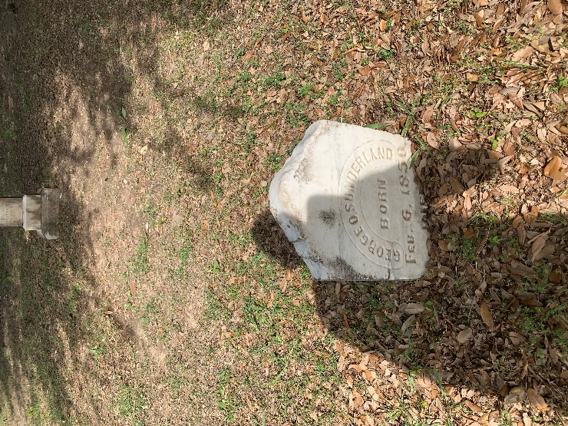 | 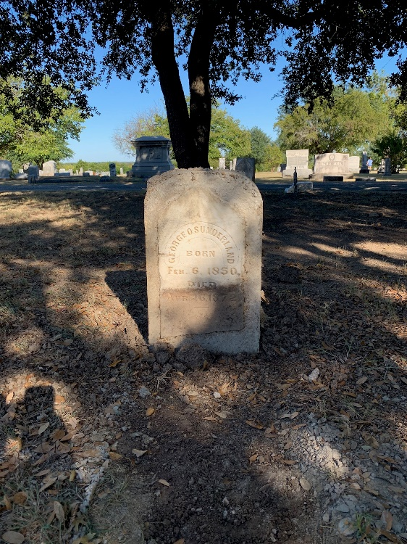
Adopted by Debbie Perkins | J. S. Sunderland | 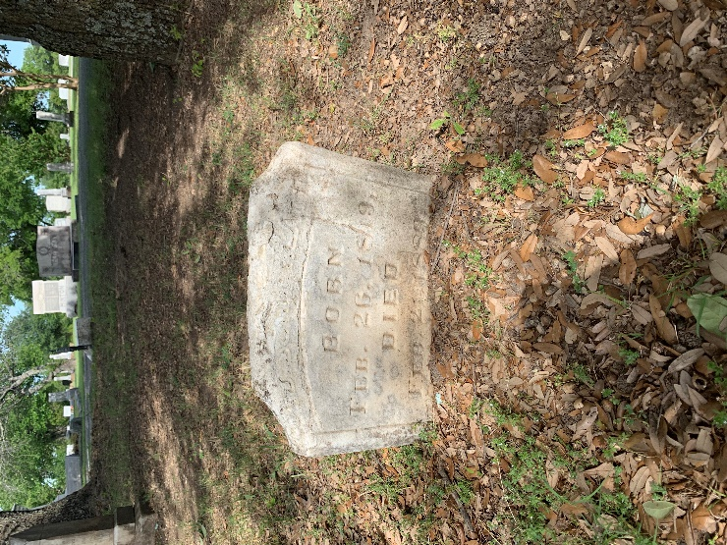
Adopted by Judy McDoough | Infant son of D. K. and E. E. Tate | 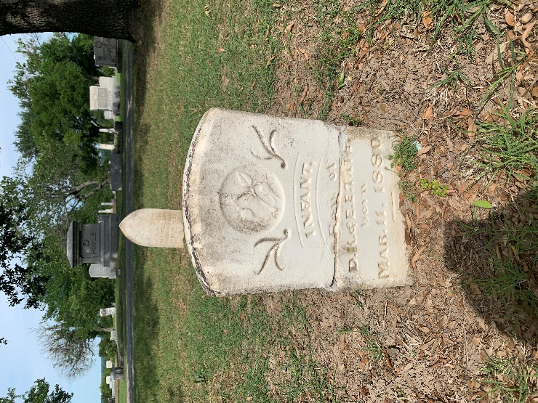 | 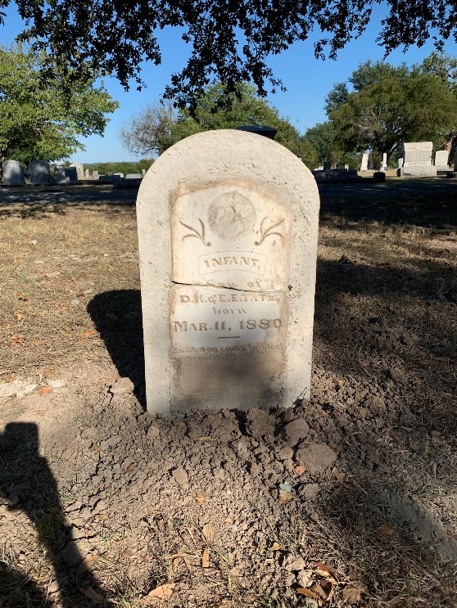
Adopted by Debbie Perkins | Infant daughter of T. W. and M. M. McMillan | 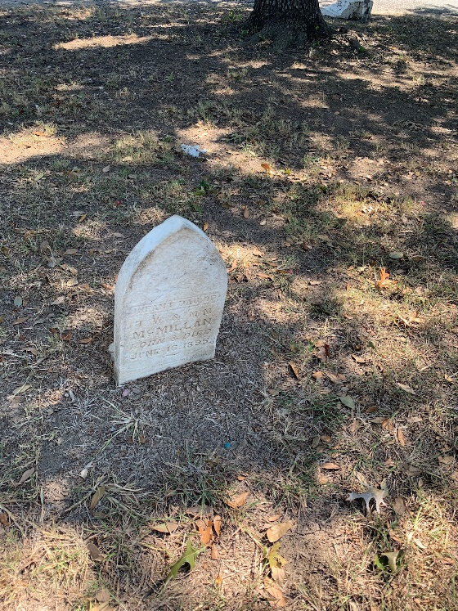 | 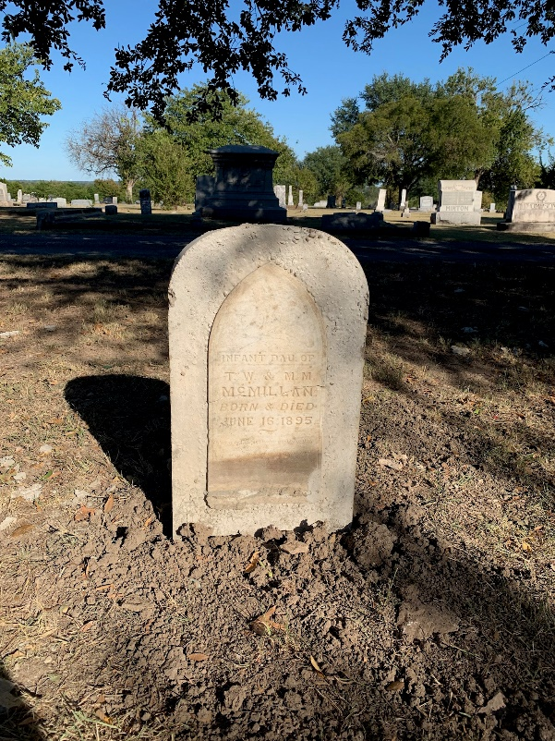
Adopted by Linda Hynds | Joseph Kelly | 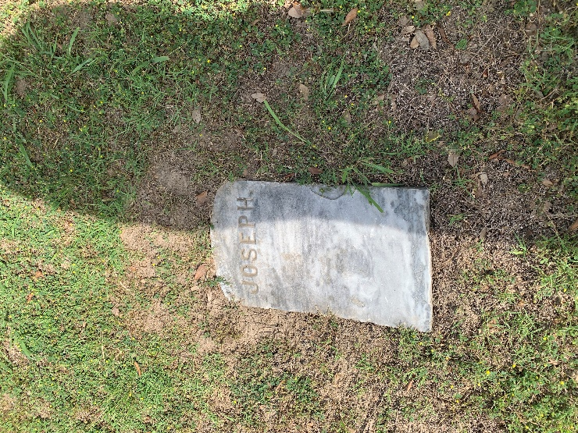
Adopted by Linda Hynds | Martha H. Watson | 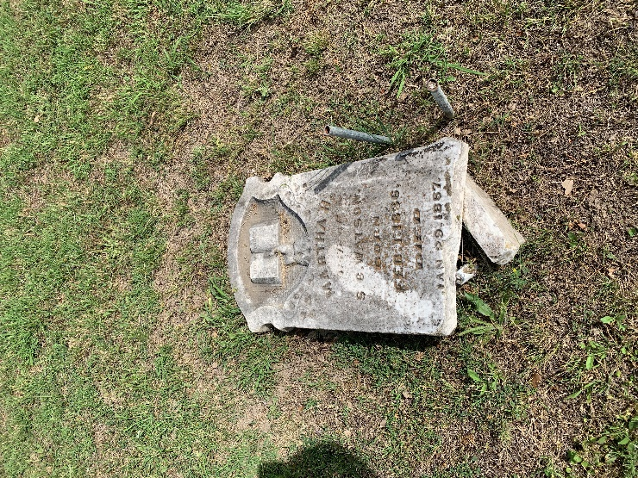
Adopted by Linda Hynds | Carl R. Gleaves | 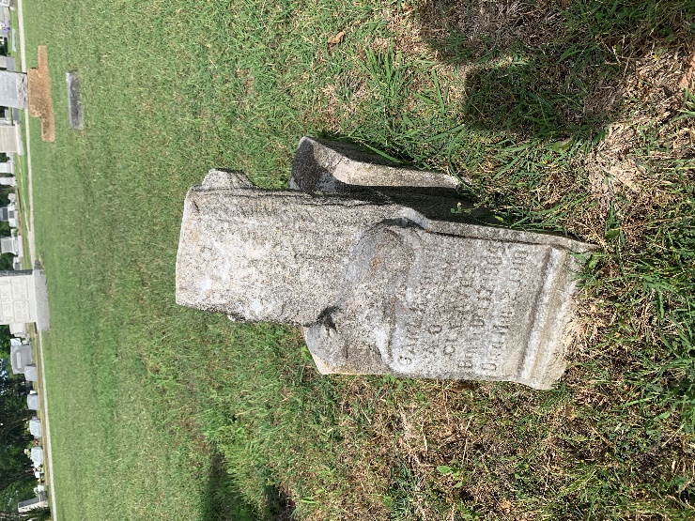
Adopted by Elaine | Francis L. Cartwright | 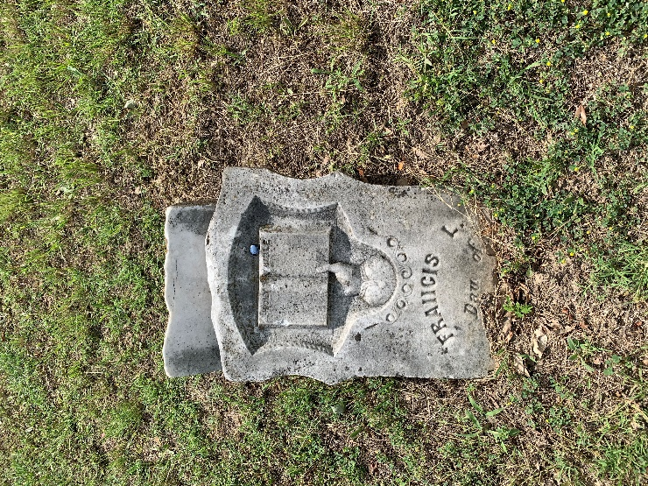
Adopted by Elaine Bay | Lourany Cartwright | 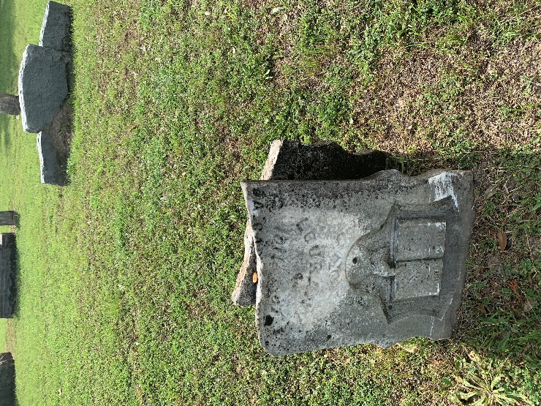 | 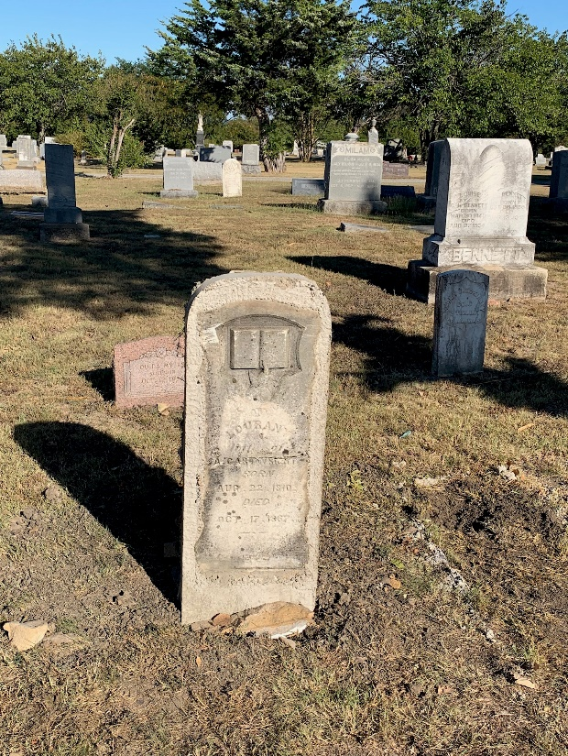
Adopted by Linda Hynds | John Clouse | 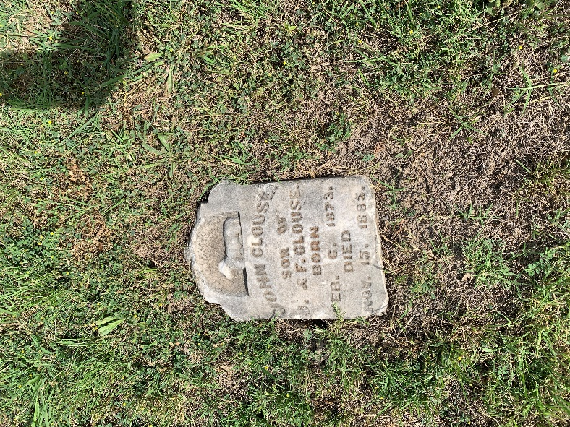
Adopted by The Boulton Family | A.S. McKinney | 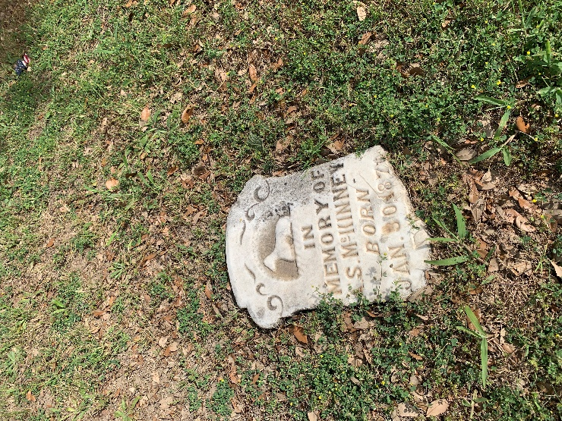
Adopted by Barbara Alsobrook | Andrew J. Hayhurst | 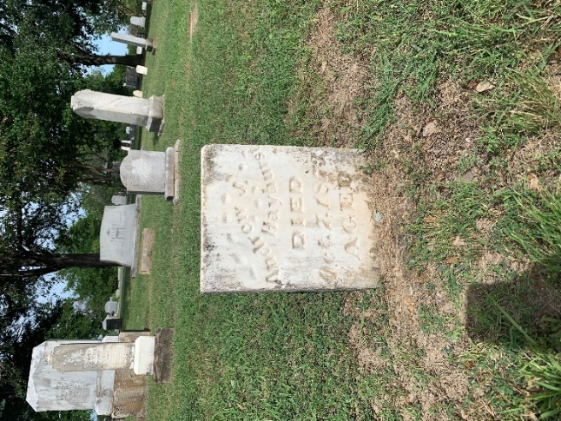 | 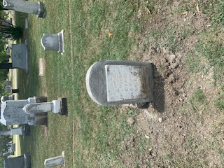
Adopted by Barbara Alsobrook | Warner Hayhurst | 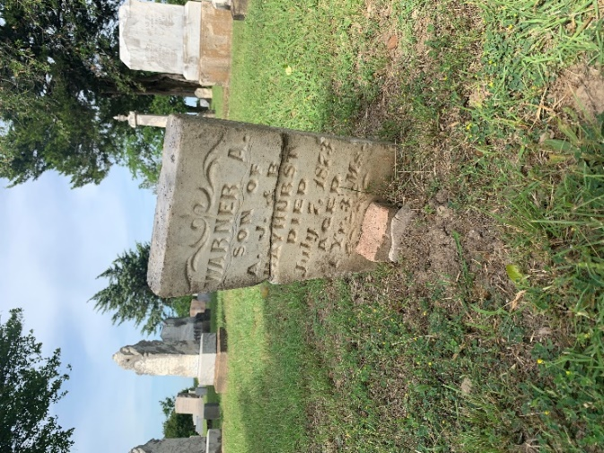 | 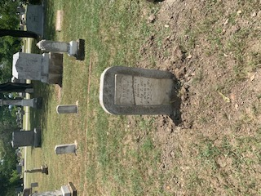
Adopted by Barbara Alsobrook | John E. Hayhurst | 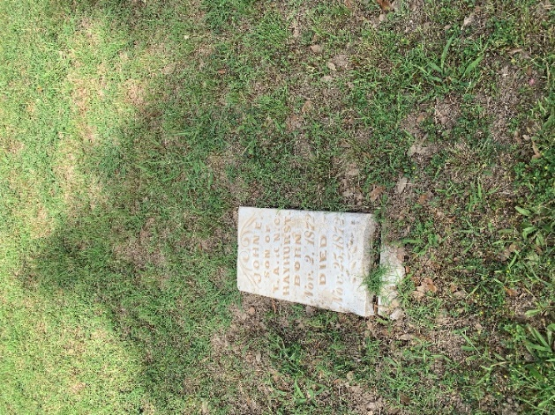 | 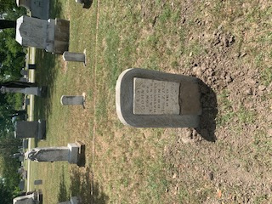
Adopted by Barbara Alsobrook | Mary E. Hayhurst | 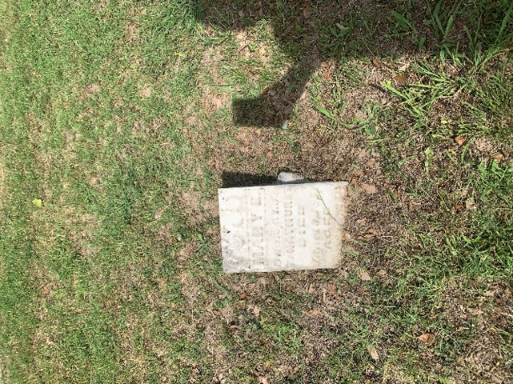 | 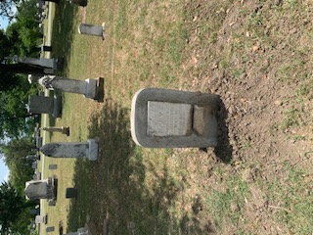
Adopted by Barbara Alsobrook | Joseph Warner Hayhurst | 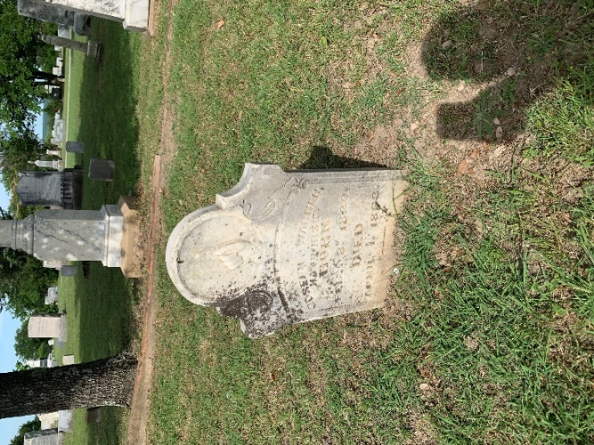 | 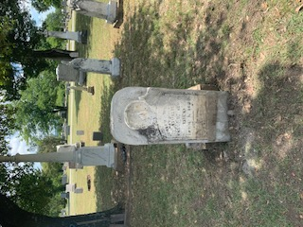
Adopted by Julie Morris | Mary A. Wells | 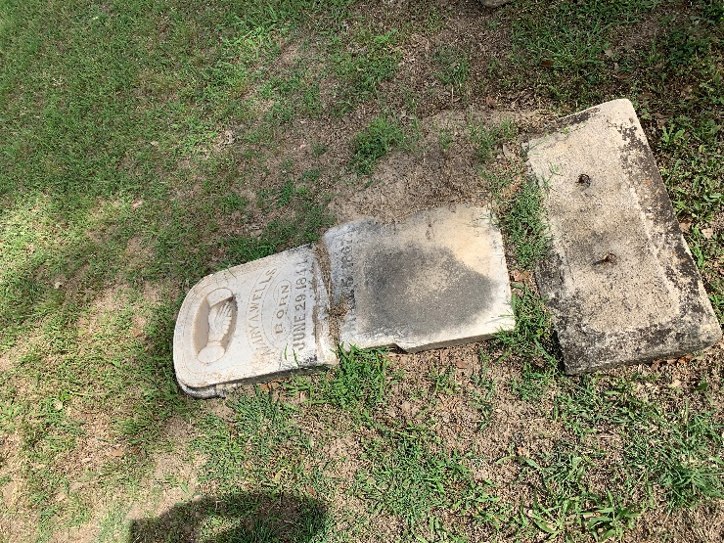 | 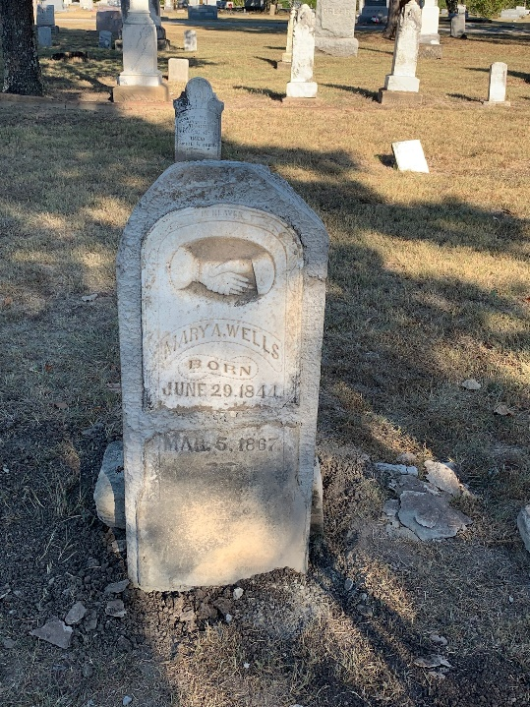
Adopted by The Boulton Family | Elizabeth Paxton | 