Adopted by The James Family | Martha H. Cartwright  This stone has been thrown around and is not in its correct spot. | 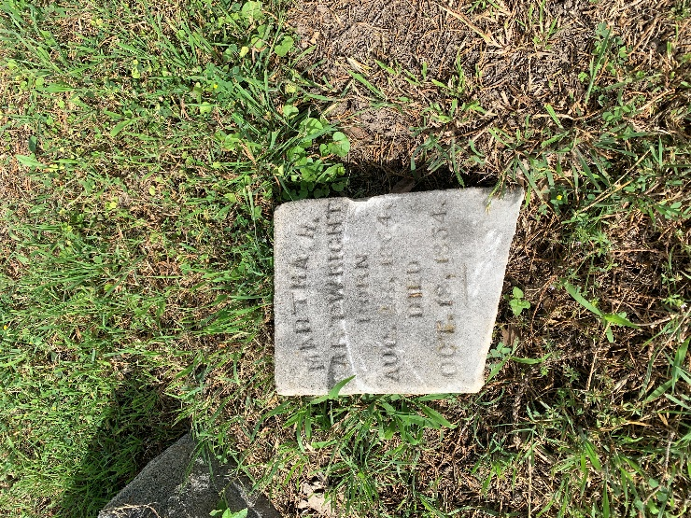 | Repaired and placed in the correct location.
Adopted by Linda Hynds | John T. Clark | 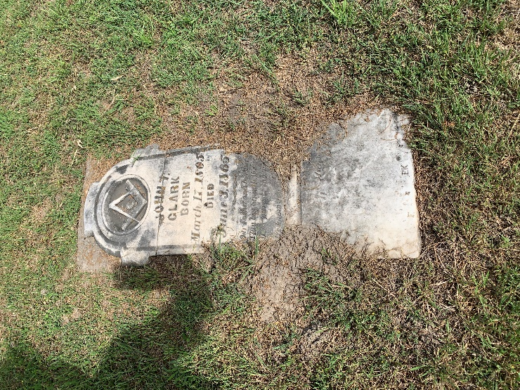
Adopted by Elaine Bay | Pennie L. Freeman | 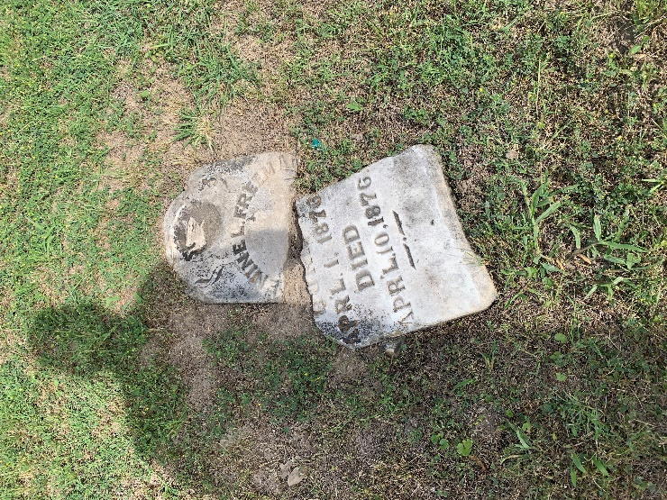
Adopted by Elaine Bay | Joel S. Enloe | 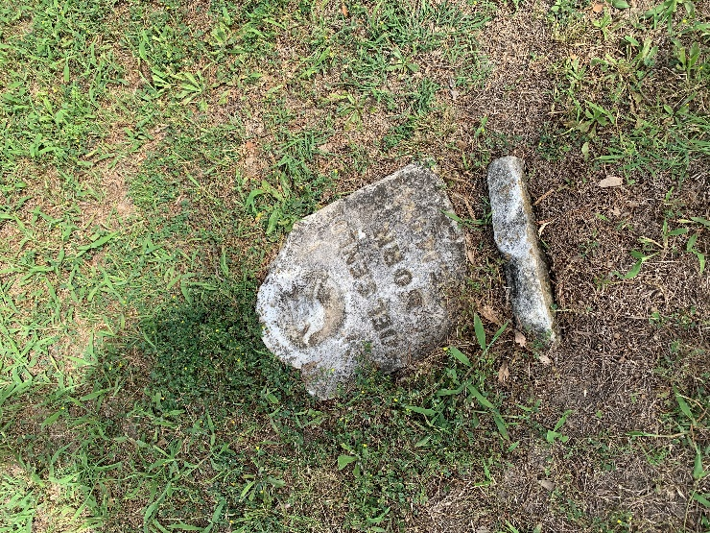
Adopted by Elaine Bay | John H. Enloe | 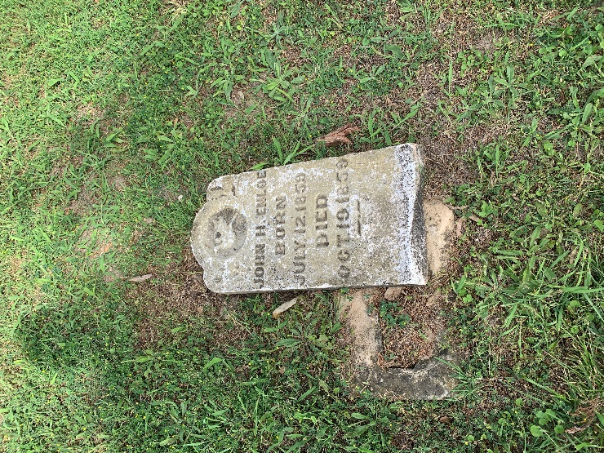
Adopted by Zack Herring | Frank G. Leslie | 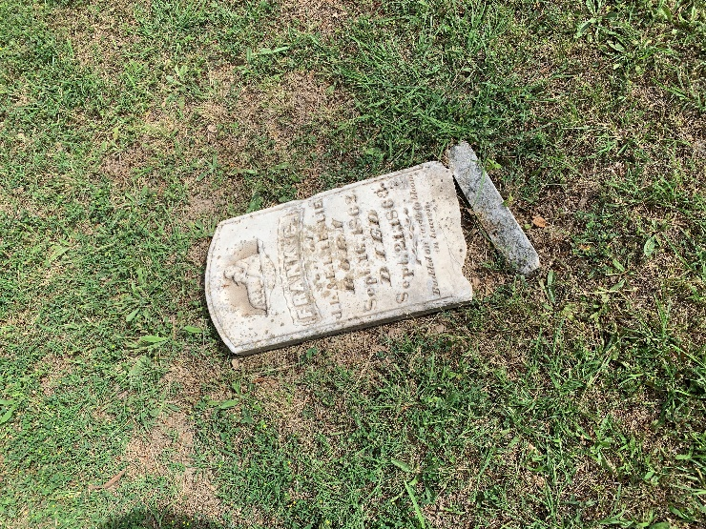
Adopted by Jay Campbell | Nancy Isabella Welch | 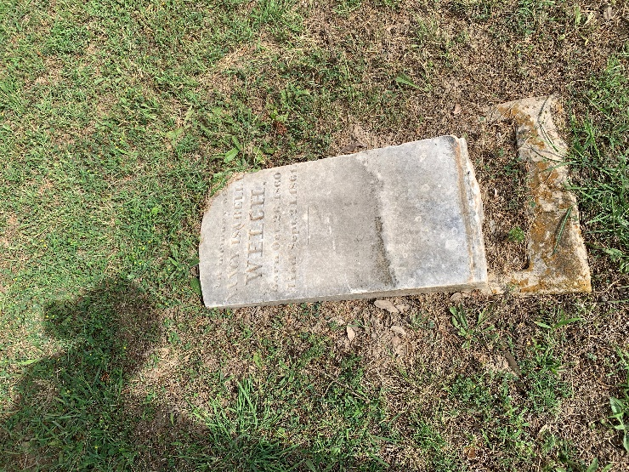
Adopted by Billy Turner | Mary Riddel1? | 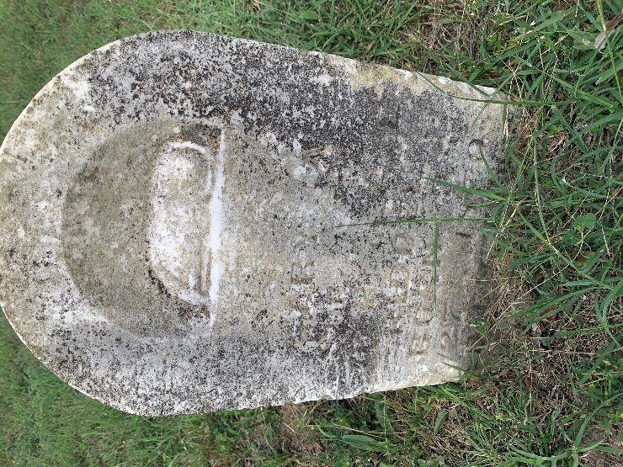
Adopted by Billy Turner | Louisa J. Sherley | 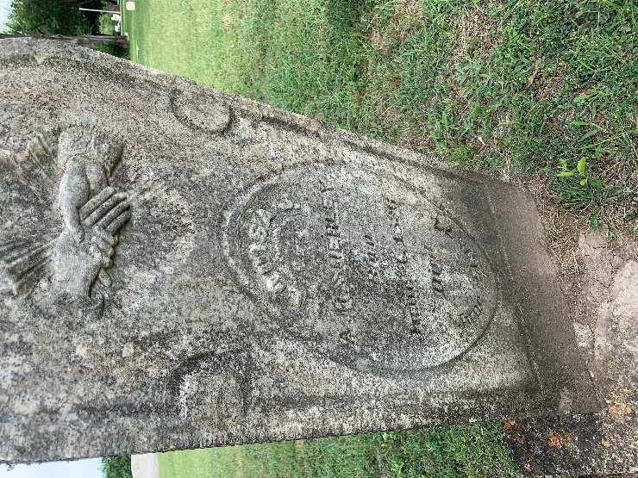
Adopted by Billy Turner | Laura J. Pickens | 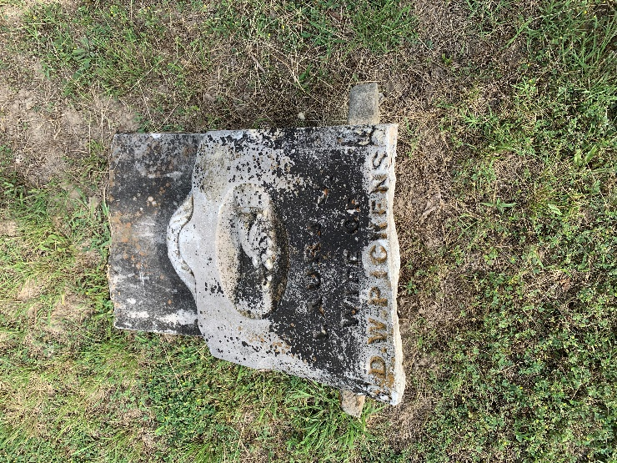
Adopted by Michael Garrison and Natalie Hill | Effie B. Jenkins | 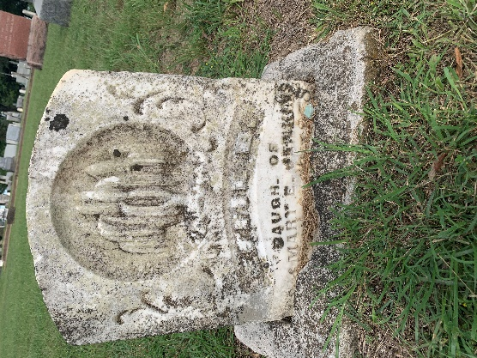
Adopted by Melanie Jones | Sallie Myrtle Umphress | 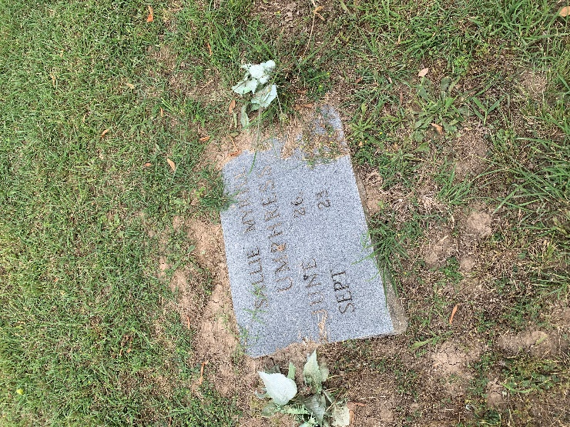
Adopted by Debra Jouglard | Dollie Lucas | 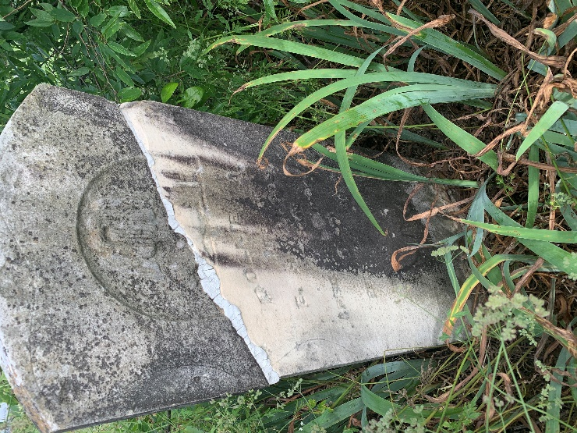
Adopted by Kelly Locke | Daniel R. Stephens | 