Adopted by Wayne and Sherry Jeffers | Chester Stephens | 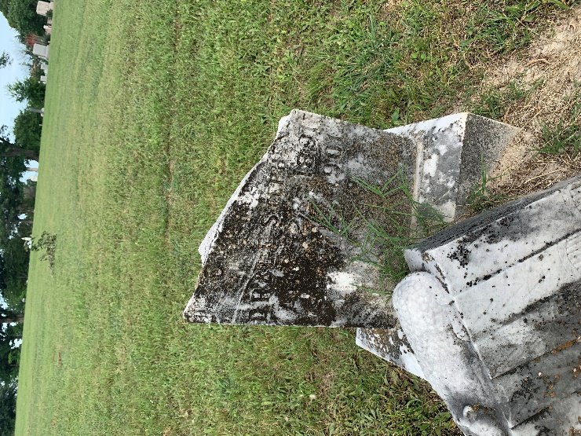
Adopted by Larry and Kim Williams | James Gheves | 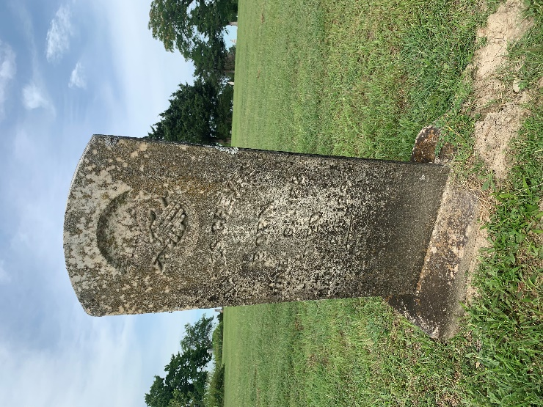
Adopted by Dorothy Bishop | Andrew J. Gregory | 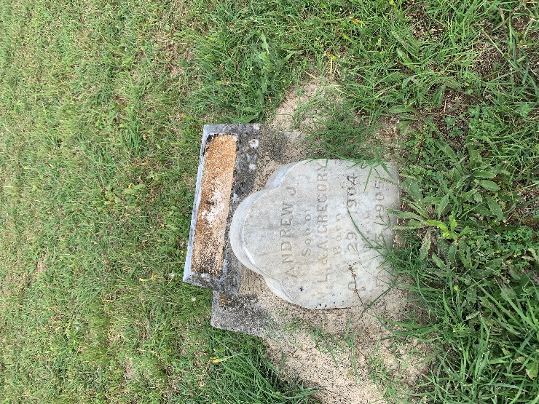
Adopted by Don Blanchard | Frances L. Burgess | 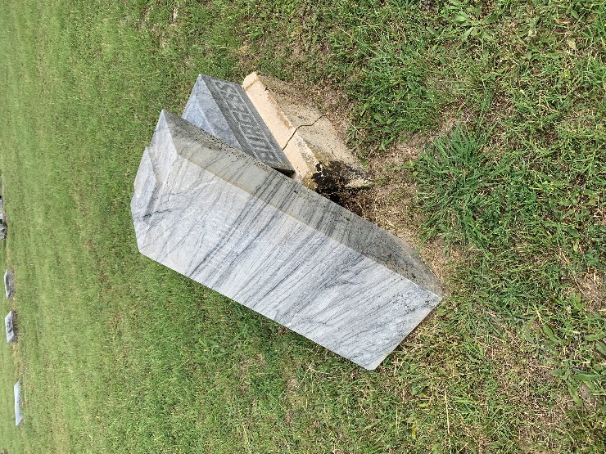
Adopted by Dorothy Bishop | Eddie Burgess | 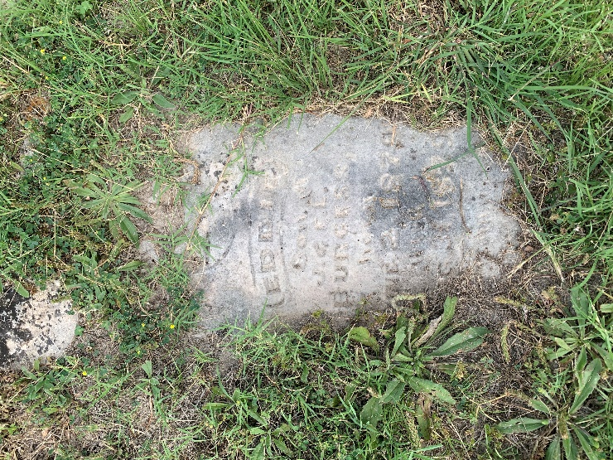
Adopted by Betty Morriss | John Gentry | 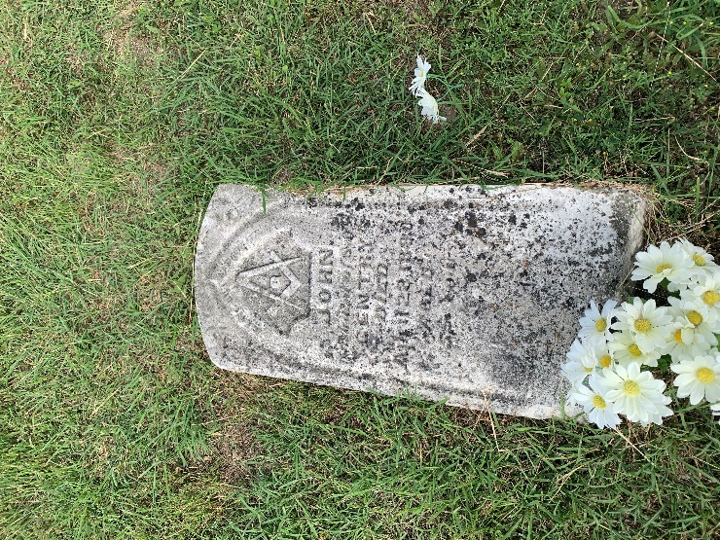
Adopted by Jerry Hamon | Addison A. Cartwright | 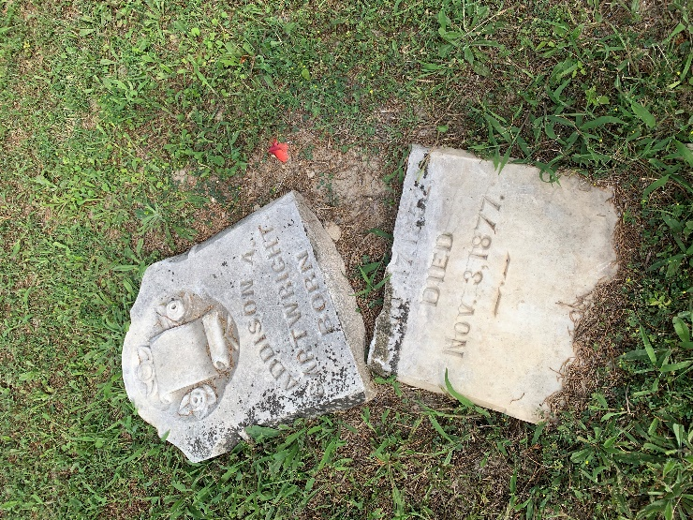
Adopted by Emily and Caroline Kendrick | Rebecca Pearl Mahar | 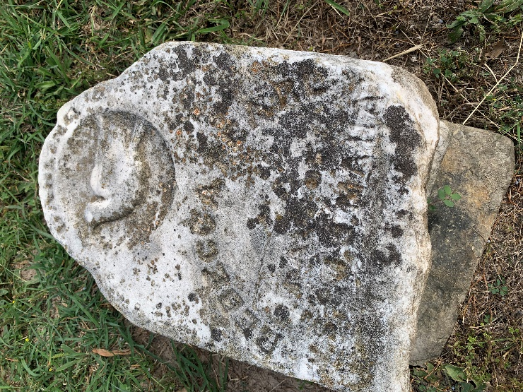
Adopted by Judy McDonough | Infant of R. S. and M. L. Henderson | 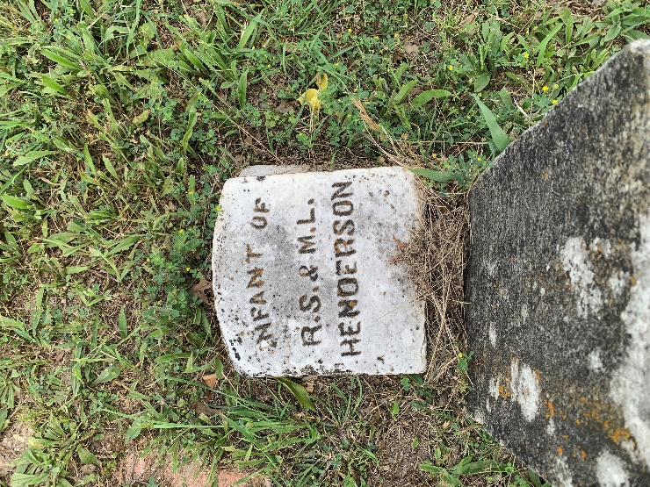
Adopted by Betty Morriss | Evelyn Henderson | 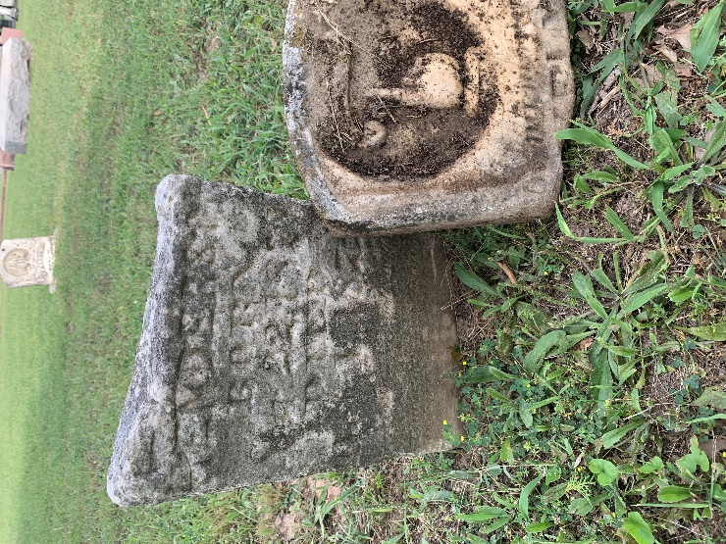
Adopted by David and Kier Whitfield | Sallie A. M. Hunter | 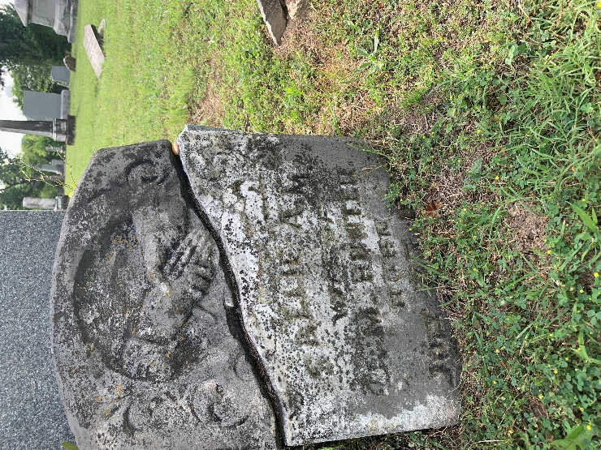
Available for adoption | John Gentry | 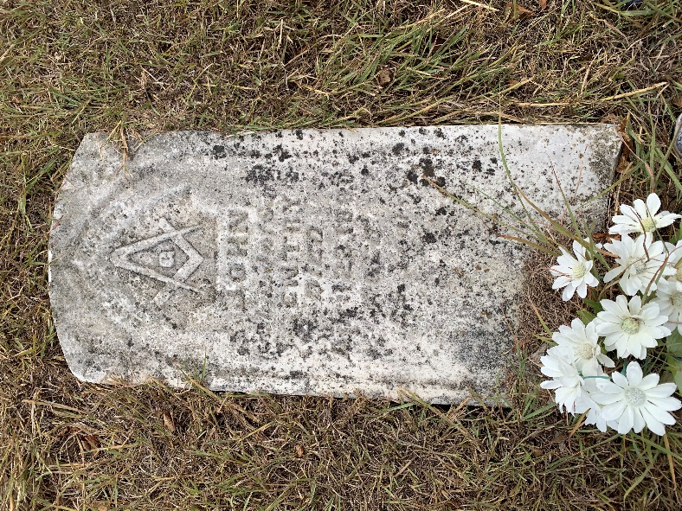
Available for adoption | Andrew Gregory | 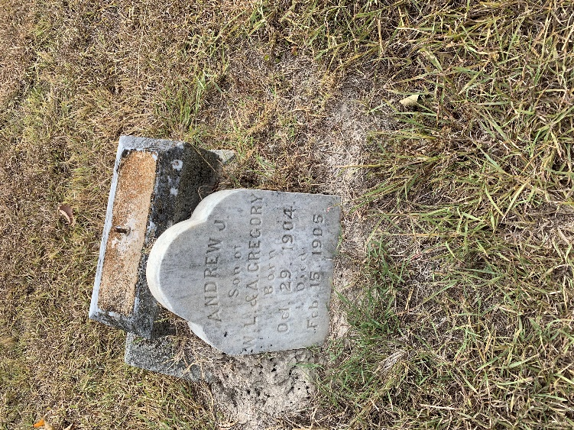
Available for adoption | Fearn Baskett  27 June 1886 - 30 September 1887  s/o G. W. & M. G. Basket | 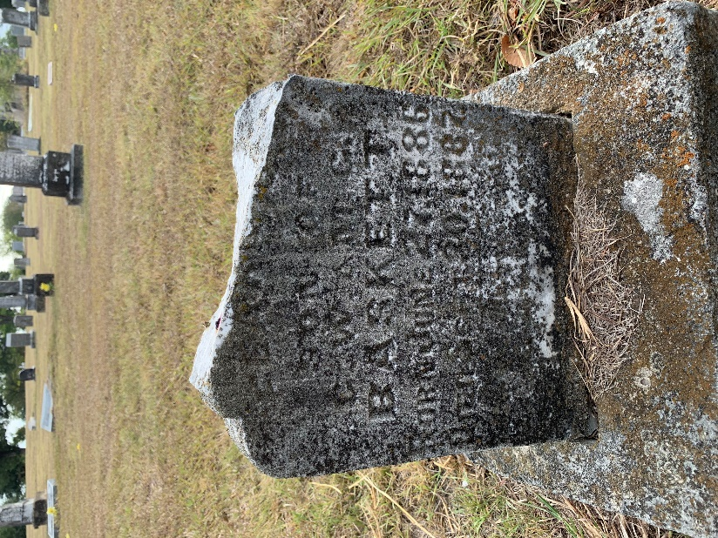
Available for adoption |  | 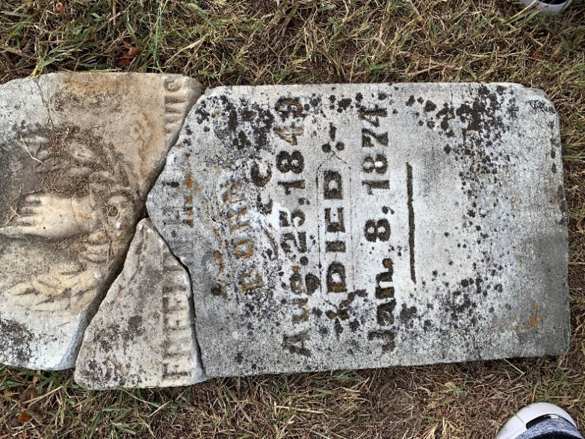
Available for adoption | Joe Fred Pattie  4 June 1873 -  s/o J. W. & S. E. Pattie | 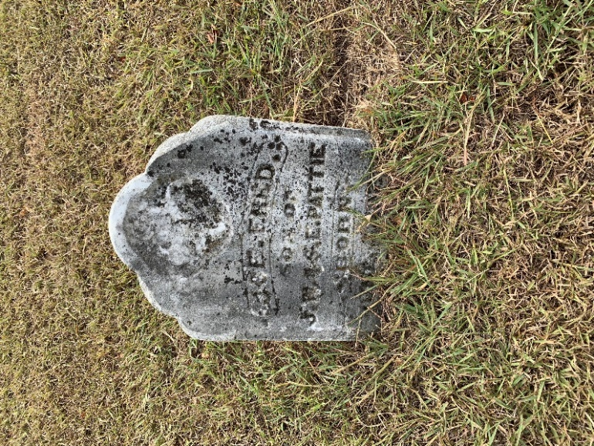
Available for adoption | James M. Greene | 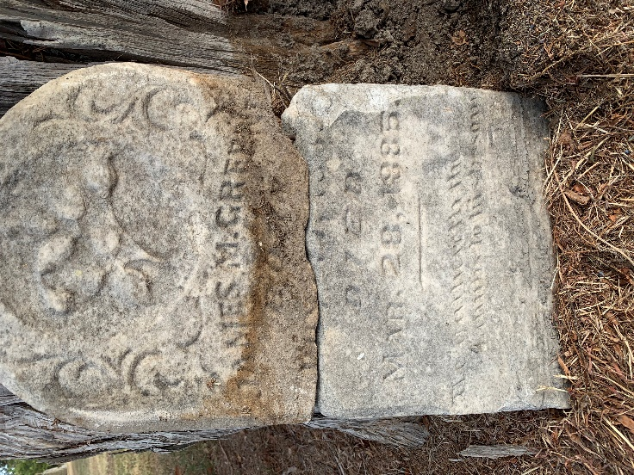
Available for adoption | Homer Greene  13 December 1878 - 13 September 1882 | 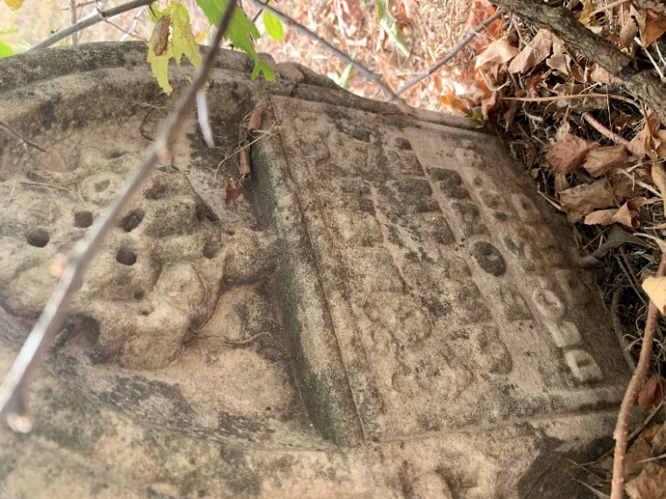
Available for adoption | Elizabeth & Lucy Greene  10 June 1881 | 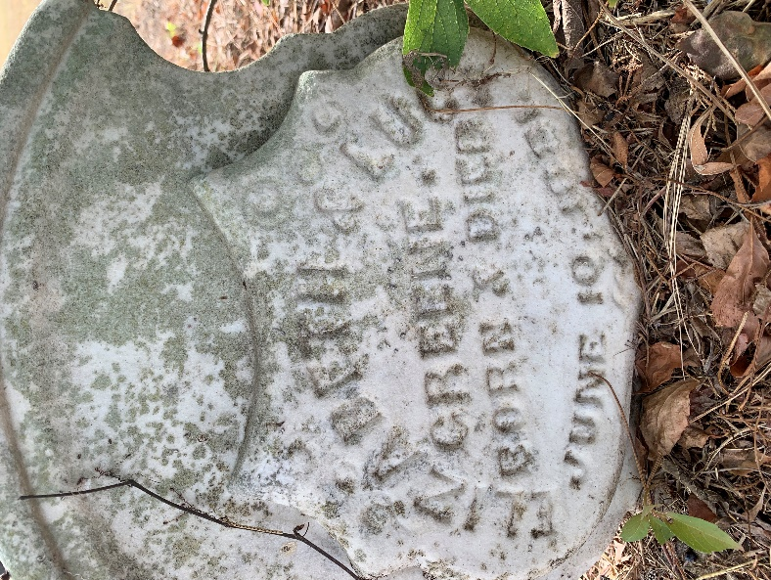
Adopted by Debbie Perkins | Near McCorkle family  Will go back and transcribe  Martha? | 