Available for adoption | Elissa J. Griffith | 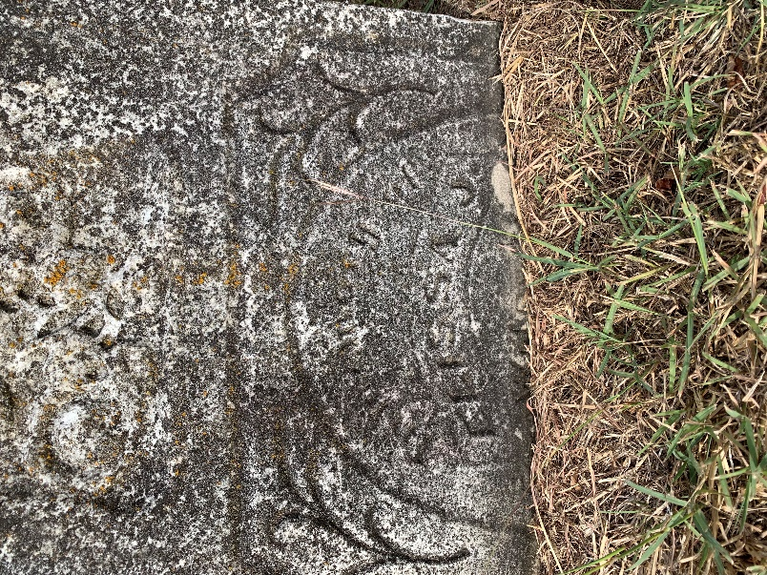
Available for adoption | Mariah Webb | 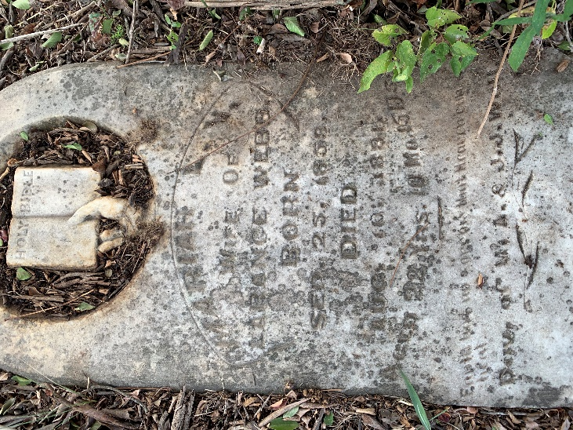
Available for adoption | Jimmy Bennett  28 February 1884 - 7 October 1884  s/o H. N. & M. B. Bennett | 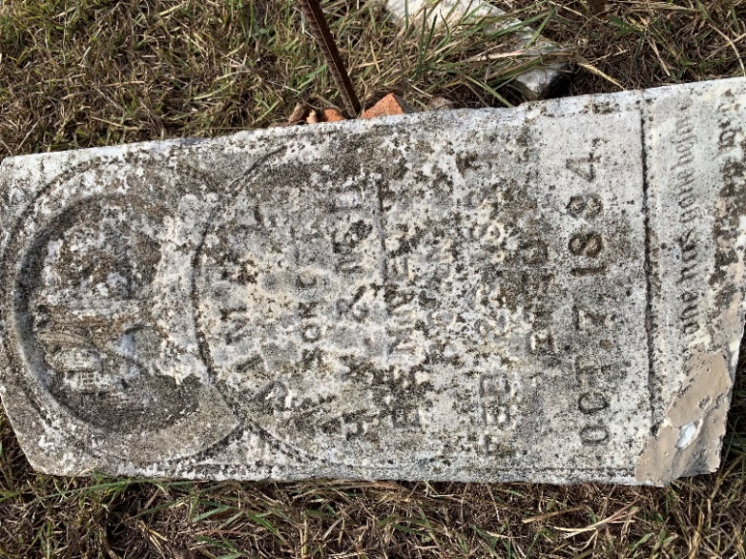
Available for adoption | John L. Watts | 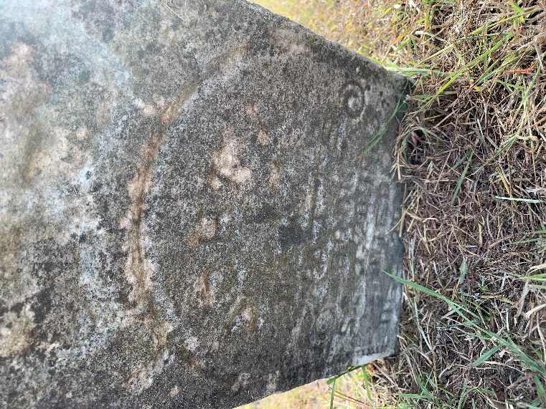
Available for adoption | Joseph Newton Watts | 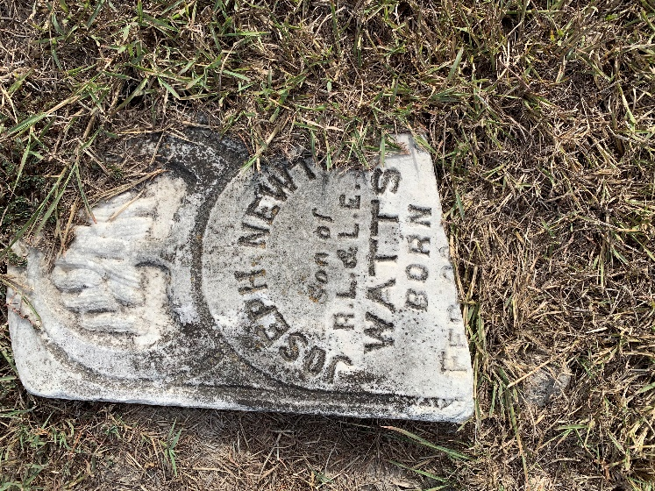
Available for adoption | Lizzie Green | 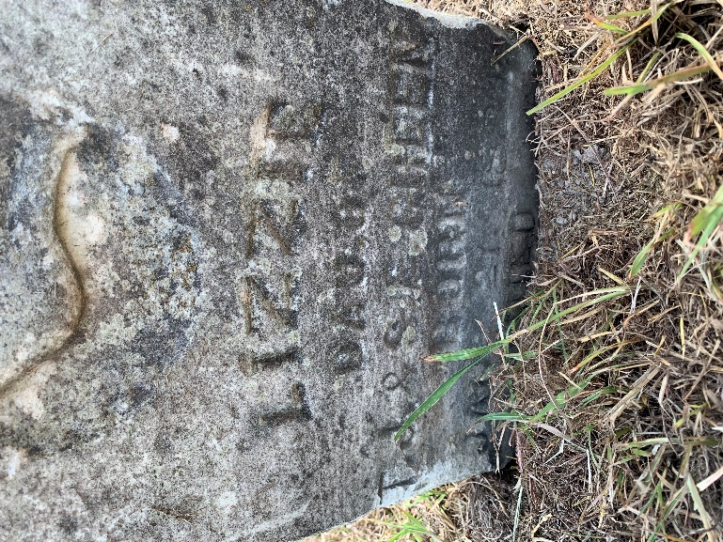
Available for adoption | Will go back and transcribe | 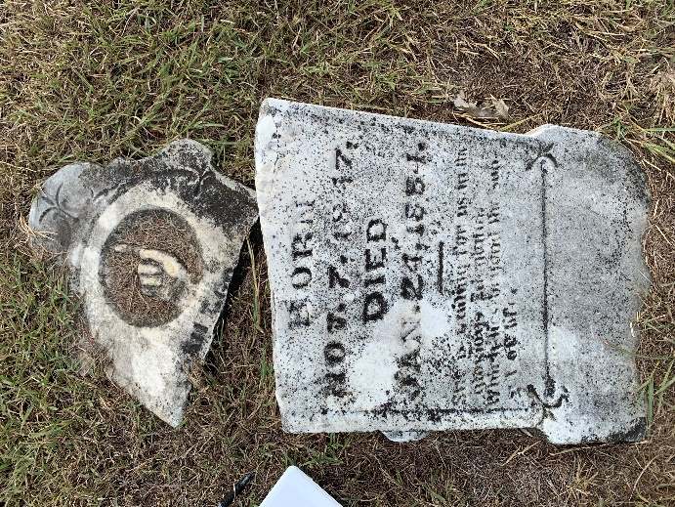
Available for adoption | Vernon Canada | 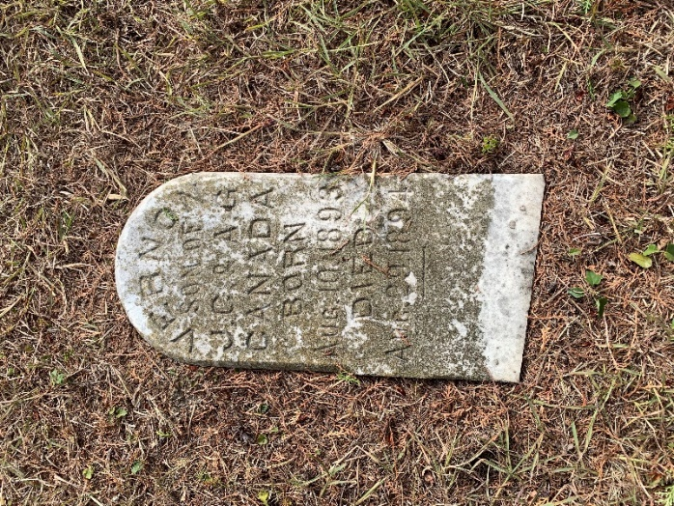
Available for adoption | Carl Oneal | 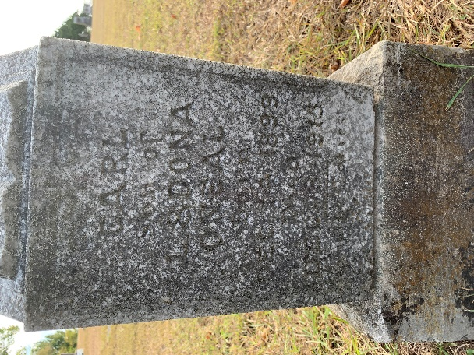
Available for adoption | Baby Gray | 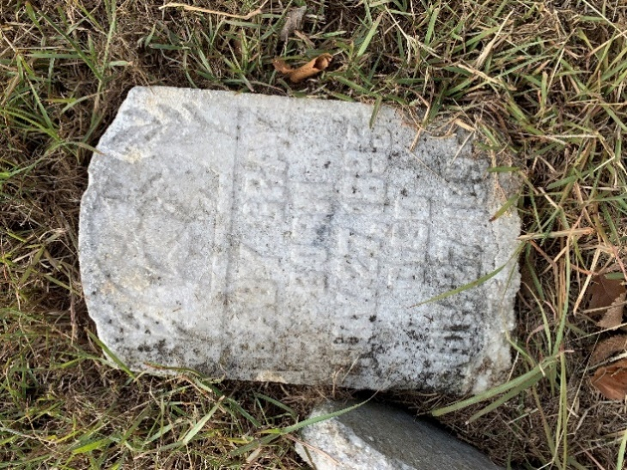
Available for adoption | Lillian Pauline Gray | 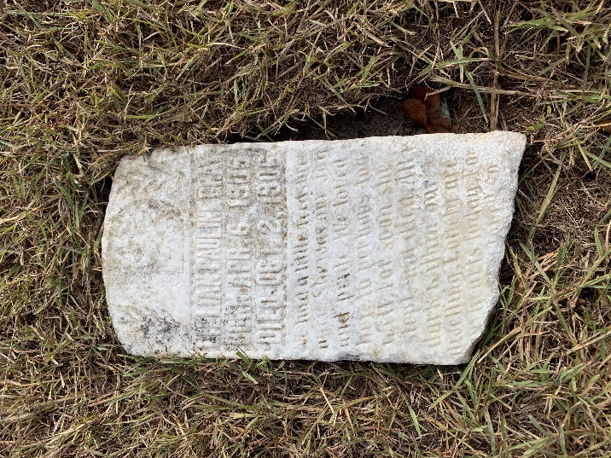
Available for adoption | Eula Belle Bennett | 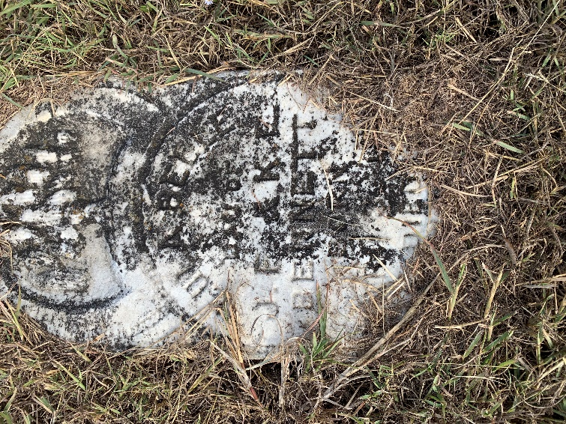
Available for adoption | Sarah J. Harrison  18 September 1844 - 11 June 1881  w/o L. B. Harrison | 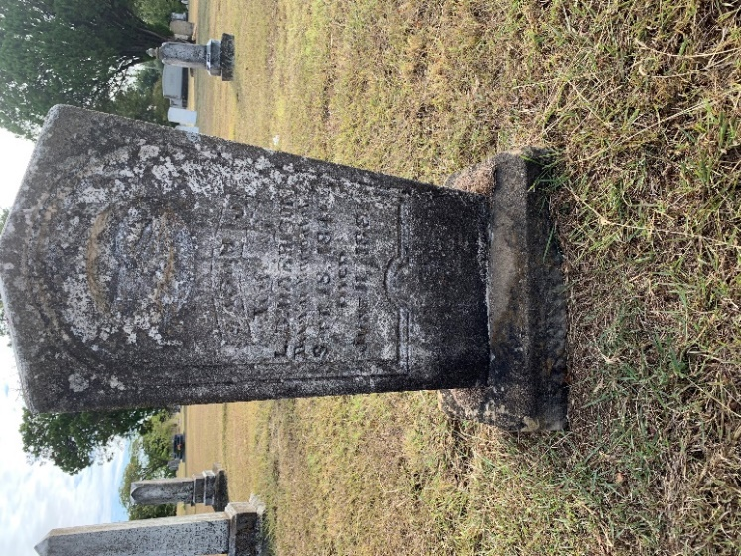
Available for adoption | Franklin Edwards | 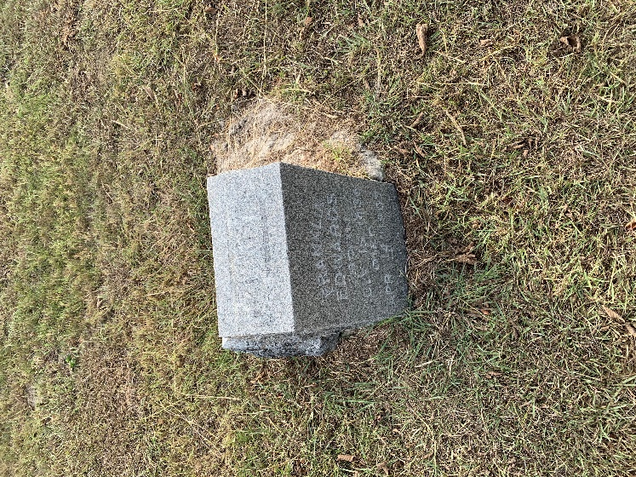
Available for adoption | Edmond Wills | 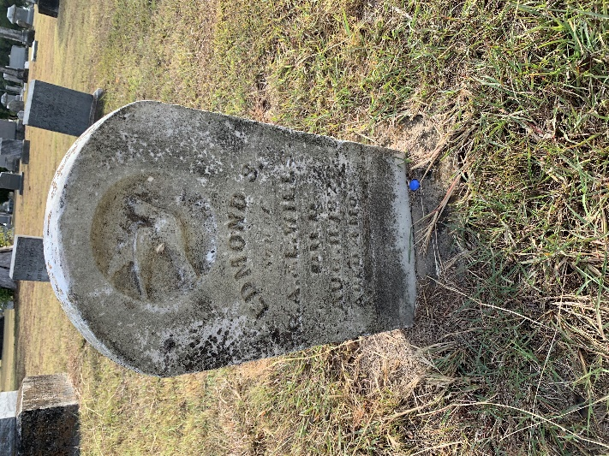
Available for adoption | Carrie Hunter | 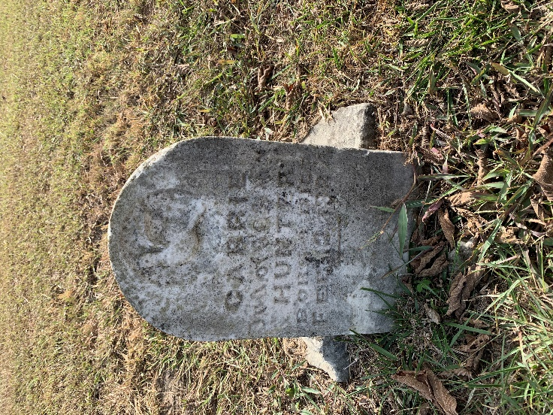
Available for adoption | Mattie Wells | 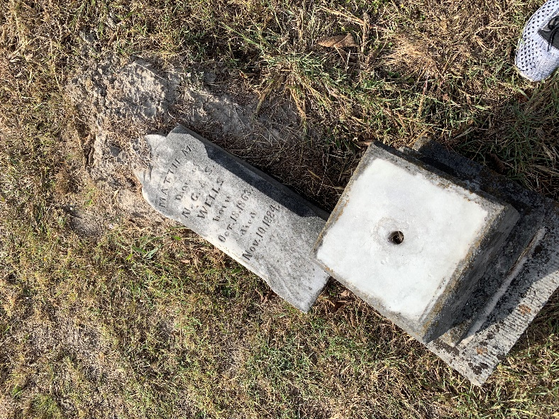
Available for adoption | Mollie Wells | 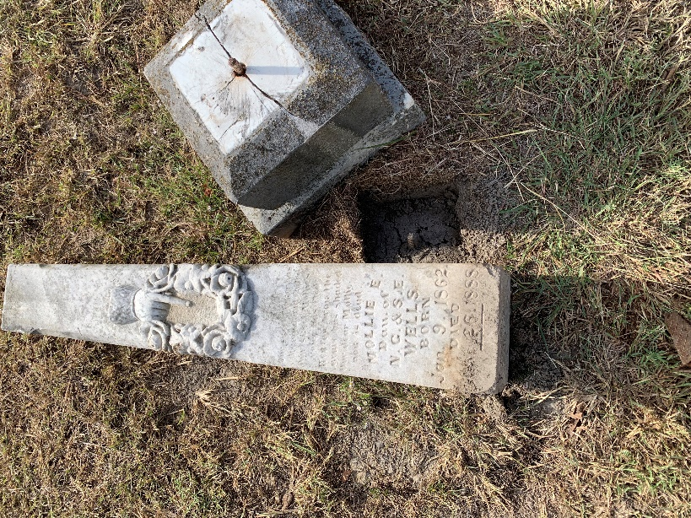
Available for adoption | Lucy Johnson | 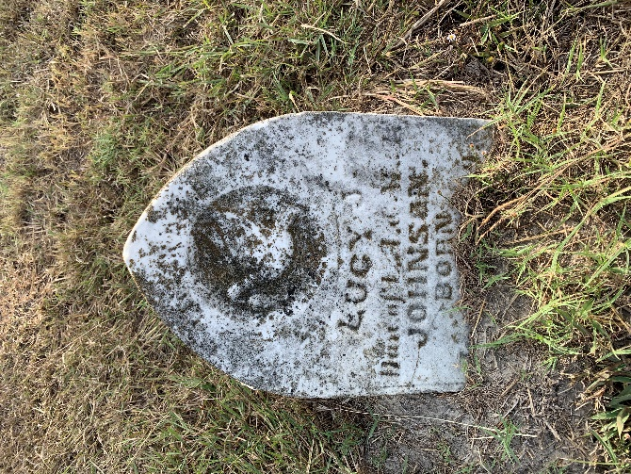
Available for adoption | Mary Skaggs | 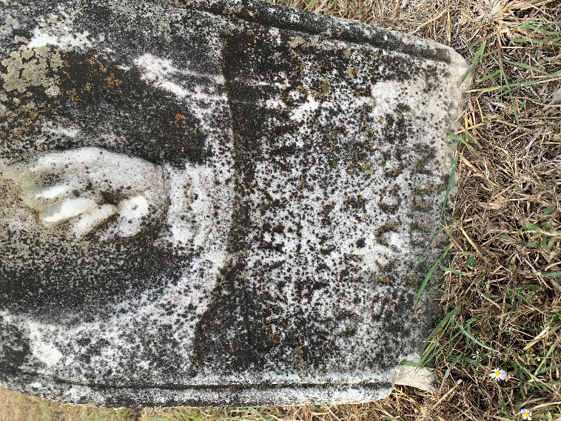
Available for adoption | 2 Unknown Graves | 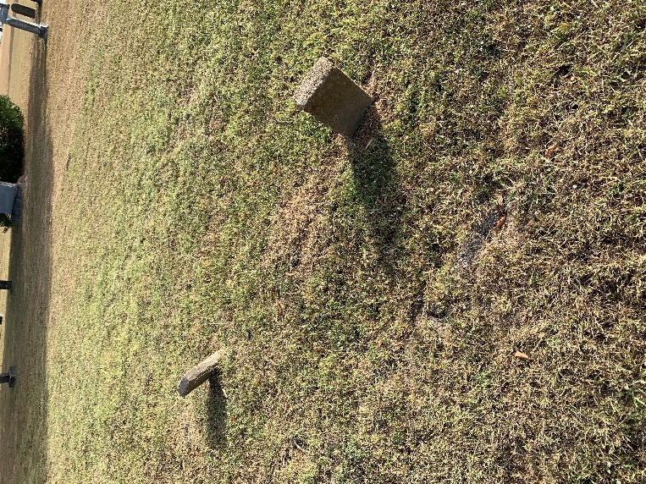
Available for adoption | William L. Cravens  5 March 1865 - 23 February 1883  s/o A. S. & H. C. Cravens | 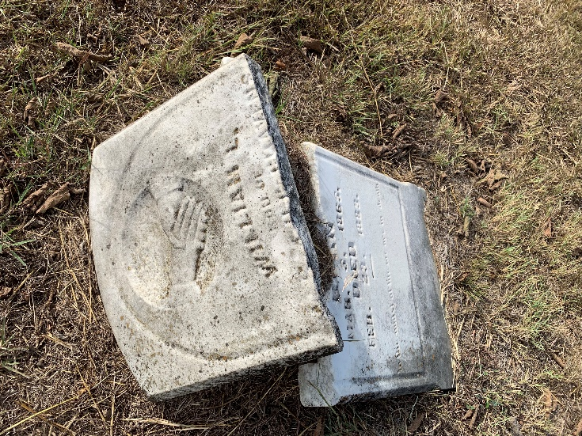
Adopted by Susan Berryhill | Leland Stanford Henderson | 